Signal Optimization Process
This process involves refining and strategically selecting search terms to enhance visibility, relevance, and ranking in digital content.

1. Signal Identification & Sorting - Initial keyword list sorted by frequency of occurrence
2. Heatmap Visualization - Used to visualize keyword frequency and distribution
3. Weight Distribution Analysis - Top keywords initially carried 70–80% of identification weight
4. Contextual Expansion - Added synonyms and contextual variations
5. Keyword Replacement & Balancing - Adjusted top keywords to carry ~30% weight, supported by secondary terms
6. Final Audit - Re-audited categories for balance and confidence

Visual Example of Keyword Heat Map:
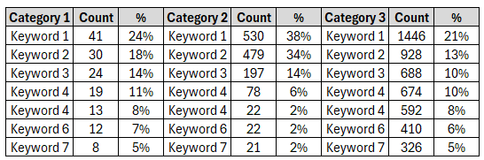 | Keyword Heat Map visually represents the frequency and distribution of keywords across a dataset, highlighting areas of high relevance or concentration to aid in pattern recognition and content analysis.

Visual Example of Keyword Identification Sheet:
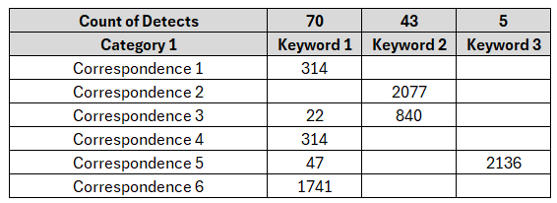 | For long emails, it was hard to tell which keyword triggered the category. So, a simple sheet was created to show where each keyword appears in the message.

Excel Tip:
- Embedding sample size calculations and corresponding audit scores within the same worksheet can significantly impact Excel's performance. To maintain efficiency and clarity, it is recommended to separate audit results into distinct sheets.
- Additionally, enabling partial or manual calculation modes allows Excel to compute formulas only after task completion, reducing processing overhead during data entry and analysis

